Solving 2nd order ODE by Method of Variation of Parameters

EXPERIMENT 3

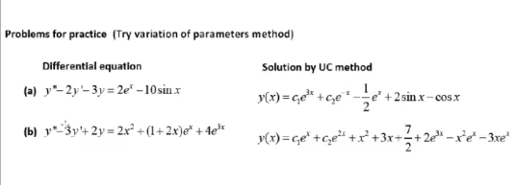

CODE:

clc

syms x r c1 c2

p1 = input('Enter the coefficient of D2y: ');

p2 = input('Enter the coefficient of Dy');

p3 = input('Enter the coefficient of y');

eq = p1*r^2+p2*r+p3;

r = solve(eq,r)

p = real(r(1));

q = imag(r(1));

if q~=0

y1 = exp(p*x)+cos(q*x);

y2 = exp(p*x)+sin(abs(q)*x);

elseif r(1)==r(2)

y1 = exp(r(1)*x);

y2 = x*exp(r(1)*x);

else

y1 = exp(r(1)*x);

y2 = exp(r(2)*x);

end

y_c = c1*y1 + c2*y2;

w = simplify(y1*diff(y2)-y2*diff(y1));

f = input('Enter the non homogenous part: ');

y_p = -y1*int(y2*f/w)+y2*int(y1*f/w);

y = simplify(y_c+y_p)

disp('The general soltuion of the given ODE is ')

disp(y)

a = input('Enter the value of a: ');

b = input('Enter the value of b: ');

c = input('Enter the value of y(a): ');

d = input('Enter the value of y(b): ');

eq1 = subs(y,x,a)-c;

eq2 = subs(y,x,b)-d;

[c1, c2] = solve(eq1,eq2);

y = subs(y);

disp('Solution of the boundary value problem is given by: ')

disp(y)

ezplot(y,[a,b])

INPUT 1:

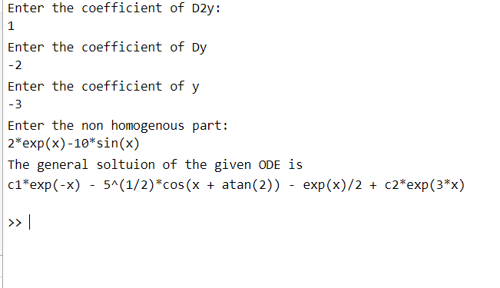

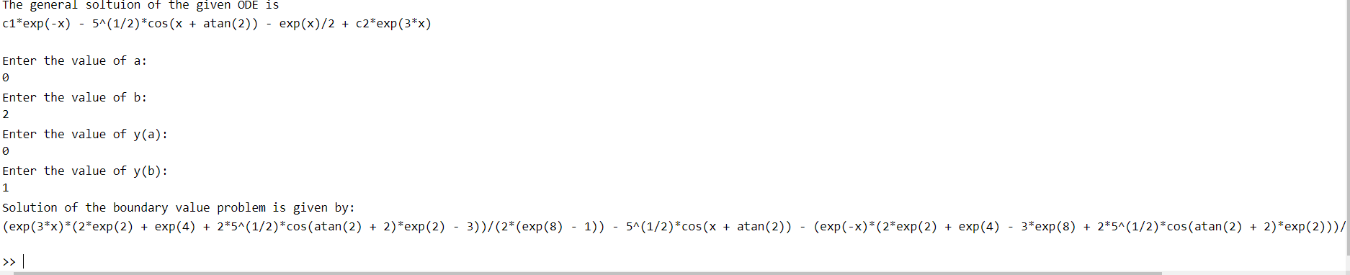

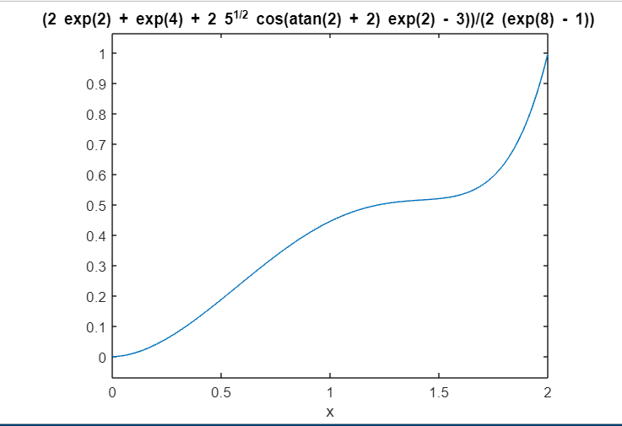

INPUT 2:

